The Ohio State University

Conceptual Design Review

Mohammed Abdallah

Faleh Alzoubi

Bella Scholtes

Victoria Smith

Engineering 1182

Dr. Meagan Ita – 8:00 a.m.

11/12/2021

Table of Contents

Concept Brainstorming & Ideation 2

Process Description 2

Brainstorming Results 2

Evidence & Revised User Needs 7

Concept Selection 8

Two concept descriptions with sketches 8

Pugh Scoring Matrix 9

Final concept Selection 10

Prototype Design 10

Description of Prototype 10

Prototype Design Requirements 11

Testing Methodology/Verification Plan 12

Correlation Matrix & Scorecard 12

Prototype Detail Design 13

References 14

Appendix A 15

# Concept Brainstorming & Ideation

## Process Description

To brainstorm, our team used Miro boards and concept maps to put all our ideas into one place so we can build off each other's ideas. The techniques we used helped us to see the different mind processes of each team member and allow each of us to build off each other. Seeing each other’s ideas also allowed each of us to see new perspectives that we could use to develop our individual concept sketches. As a team we wanted to prioritize mapping out each of our ideas clearly so each member could easily trace how the person came to that idea. We faced no constraints while brainstorming because we all took the time to follow each other’s thought processes which led to some great ideas that would later be developed into updated concept sketches.

## Brainstorming Results

While brainstorming, each member mentioned many varying ideas that ended up benefiting all our individual sketches. Ideas about the material, ventilation, charging capabilities, portability, etc. were all discussed while brainstorming.

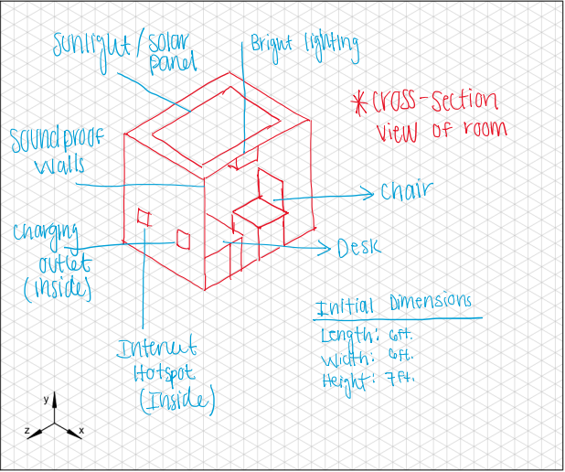

Initial concept sketch (Faleh)

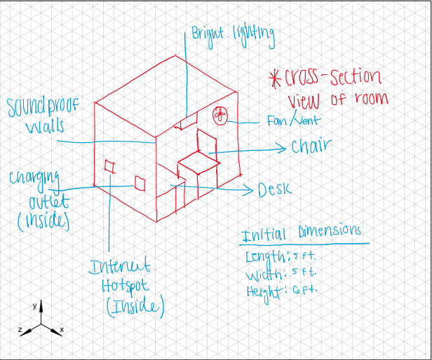

Revised concept sketch (Faleh)

After brainstorming with the team and reviewing input and feedback from the industry leaders a couple of changes to the initial design were made. The sunlight/ solar panel features were removed as our design is meant to be used in an indoor environment. Furthermore, a fan/vent was added to the design to help with temperature control and additional comfort. Finally, the dimensions were reduced by one foot in each direction to make the design more practical and easier to move.

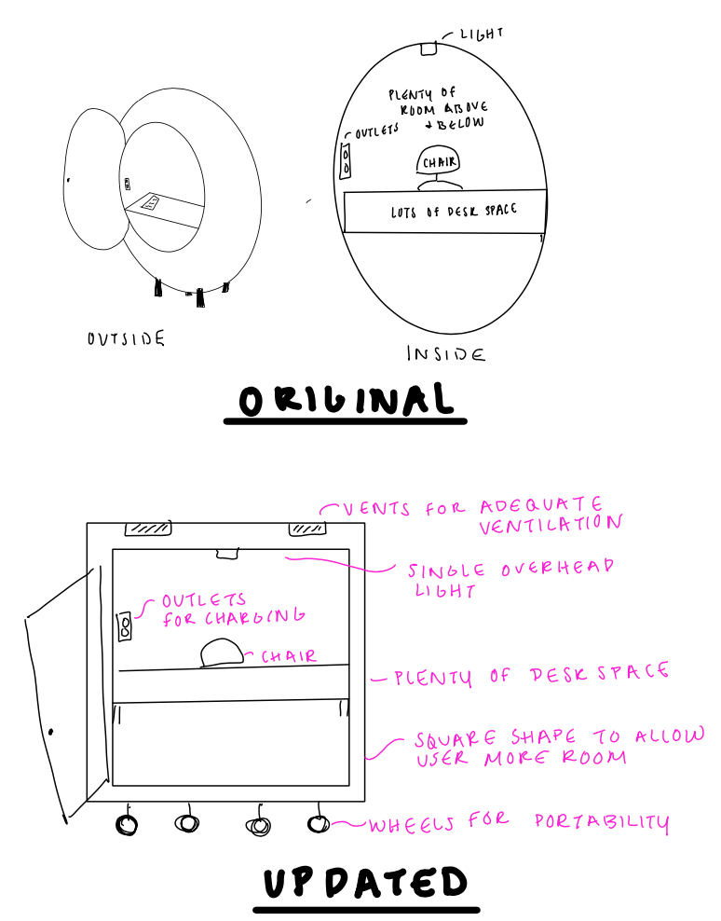

(Bella Scholtes)

After brainstorming, my concept changed by adding more space and portability after we identified that portability was an important user need. My updated concept sketch includes wheels for better portability and also is a square object in order to allow the user even more space to do their work. I also added vents at the top of the pod in order to allow better ventilation which was a concern brought up during brainstorming.

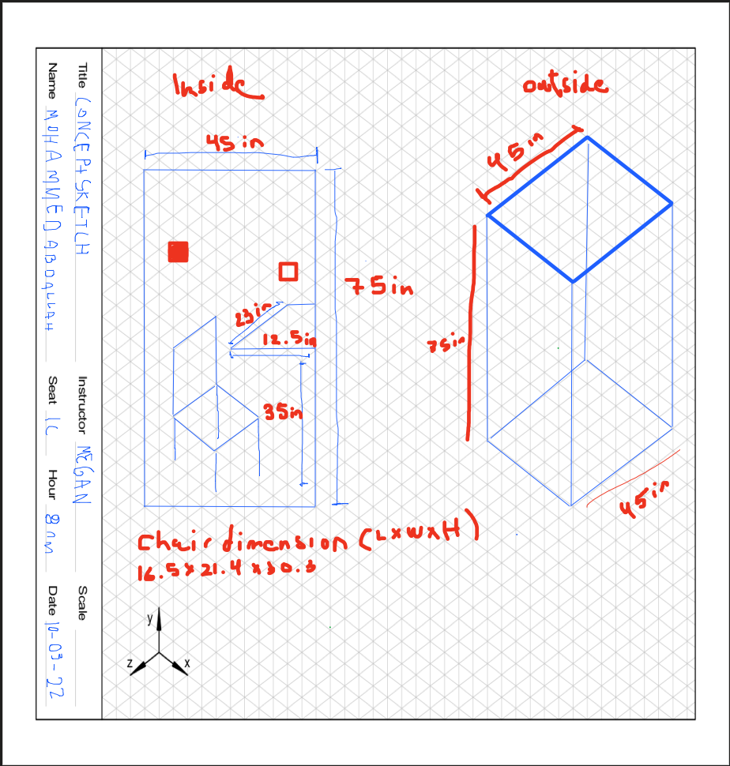

Original Concept Sketch (Mohammed)

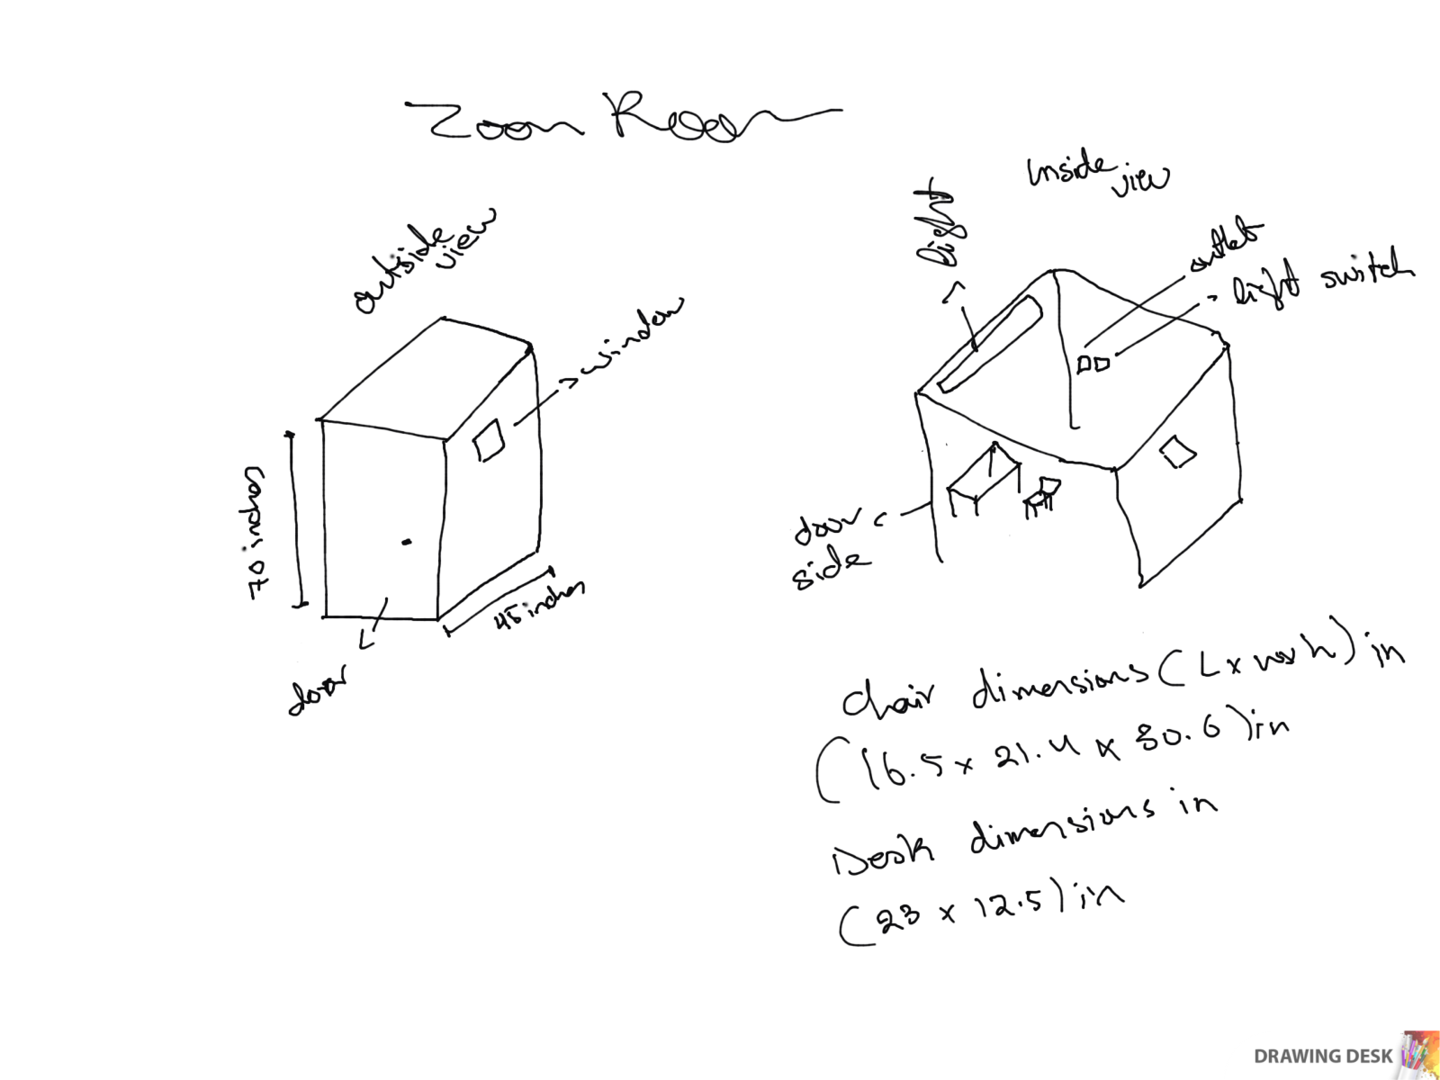

Updated Concept Sketch (Mohammed)

After meeting with the industry leaders and my team and take the advice into consideration, I decided to add a window to the design, another major thing was I made the height smaller, went from 75 inches to 70 inches. The change in size makes it more accommodating in smaller areas. It includes, light, soundproof walls, outlets and of course a desk and chair.

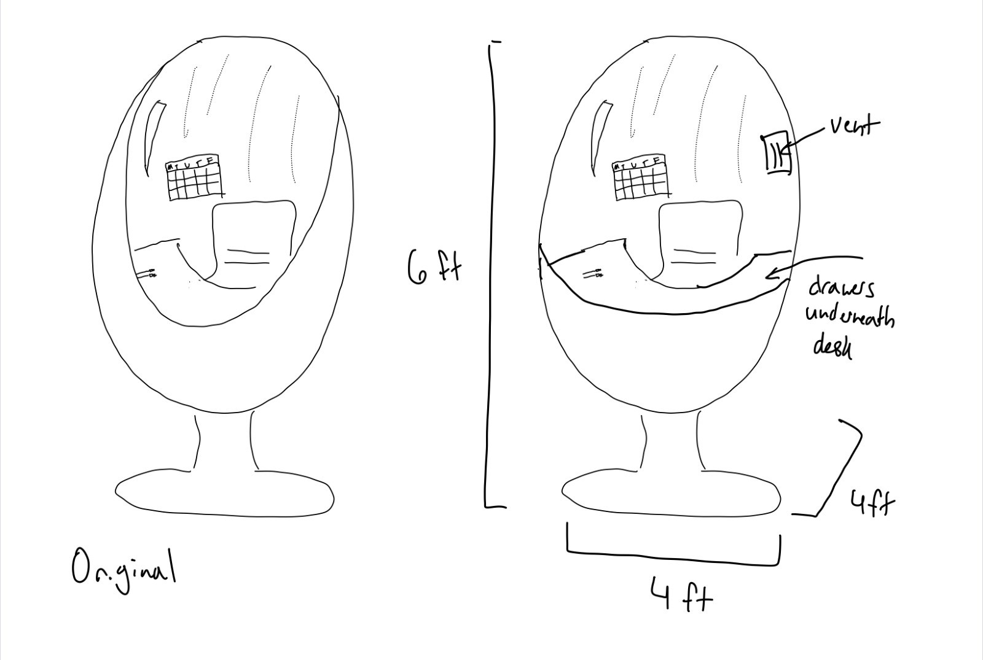

(Victoria Smith)

The first change made was to add size specifications. The industry mentors had some questions about this, so I realized it would be important to include in the design. I also decided to add other factors after the brainstorming session. One thing we discussed was ventilation, and I thought that would be very important to add to the design. Additionally, I thought about how I would want the maximum sunlight to come in because that creates a more inviting environment, so I made the window on the top larger. Finally, drawers were added underneath to help keep the user organized.

## Evidence & Revised User Needs

Our team generated these ideas after consulting with the industry mentors. After hearing their individual feedback, we started brainstorming what we each could add to our concepts and how we could improve our product. The mentors brought up ideas of portability, ample desk space, and how we could expand our primary users to anyone who needs a quiet space to work. Our user needs chart now includes portability after discussing our product with possible primary users. We decided that in order to have our product be the most efficient it has to be portable and be able to move in between buildings for wherever someone might need a quiet place to study. Our user needs to be able to have a quiet place to study in locations like airports, libraries, dormitories, or anywhere that the user seems fit. Therefore, our product needs to be able to fit in most doorways or have some sort of easy assembly.

User Needs Chart

|  |  |
| --- | --- |
| User Needs | Score (1-5) |
| A quiet environment | 4 |
| A comfortable / ergonomic setup to do work | 3 |
| To get work done efficiently | 3 |
| To be able to speak and listen on zoom calls | 5 |
| An inviting environment that motivates the user to get work done | 2 |
| Be able to charge multiple devices | 1 |
| Desk space to take notes or do work | 4 |
| Light enough that it can be moved in and out of a building | 3 |
| Small as possible while giving enough desk space | 3 |
| Portability | 4 |

# Concept Selection

## Two concept descriptions with sketches



The first concept sketch we chose is pictured above and meets most of the user's needs. It is a simple “cube-like” shape with the dimensions of 5ftx5ftx6ft. It includes features such as soundproof walls, charging outlets, internet hotspot, bright lighting, fan/vent, desk, and chair. These features work to address the many user needs of our design. The desk and chair provide a comfortable and ergonomic space to do work that also has plenty of space. The soundproof walls provide a quiet environment where one can talk and listen without bothering others. The charging outlets and internet hotspots are to address the user’s technological needs. The fan/vent and bright lighting address the comfort and create a motivating environment. However, this design fails to meet the user needs of portability and weight requirements.

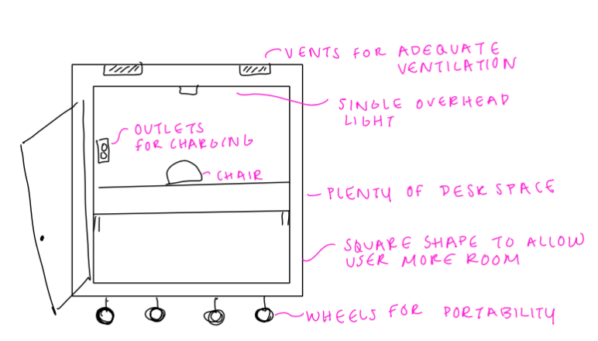

This concept sketch considers all of the updated user needs that we determined needed to be added. This design has wheels for it to be portable to any workspace, library, etc. that it would need to be transported into. It also has features like outlets for any charging necessities and a single overhead light for subtle, non-distracting light. This design also covers functional needs for the user like overhead vents for proper ventilation and plenty of desk space so the user can spread out while they work. There is enough space for the user to comfortably fit a computer and a notepad/iPad so they can work efficiently in the space. This design provides all the functional and comfortability needs that the user might find useful and allows the user to have a quiet, comfortable place to get their needed work done.

## Pugh Scoring Matrix

We based most of our needs off of those listed in our user needs charged, and then we added some user needs based on feedback from industry mentors. They had concerns over the size and portability of our product, so we added these needs to our chart. For the first few rows about having a quiet environment, we ranked Faleh and Bella’s designs the same because they both did an equally good job at addressing these needs. Both had charging ports, lighting, plenty of deskspace, and several other factors that addressed these needs. Where these two designs differ is that Bella’s can be moved around and is pretty light while Faleh’s is not designed to be portable. Thus, we ranked Bella’s design higher on the categories of being small, light, and portable.

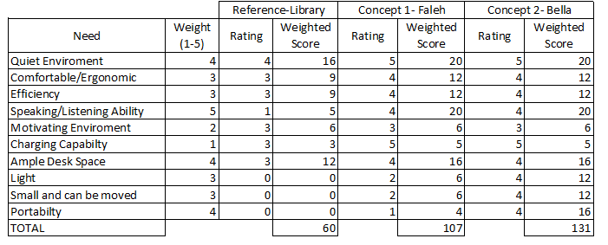

## Final concept Selection

Based on the results of the Pugh Score Matrix, we will be moving forward with Bella’s design. Both designs would create good environments where a user can comfortably speak and listen to a zoom call. However, Bella’s design is more portable and would take up less space. This is an important factor in the practicality of the design, so we will use Bella’s design.

# Prototype Design

## Description of Prototype

Based on the final concept sketch shown above, our final prototype will be in the form of a SolidWorks design. The final level of prototyping we will reach will be the “prototyping” stage due to the wide range of limitations and delimitations we will encounter. This pretotype will be used to gauge and generate interest in our idea and product. With additional resources, we then can advance to other levels of prototyping. Online tools and simulations will be used to test and showcase our design and product. Some of the limitations associated with this stage include, size, weight, quality, resource, manufacturing and cost constraints as well as general logistics concerns. Some delimitations include our limited design and manufacturing skills and experience. More so, time constraints as well as the scope of this project are also limiting factors.

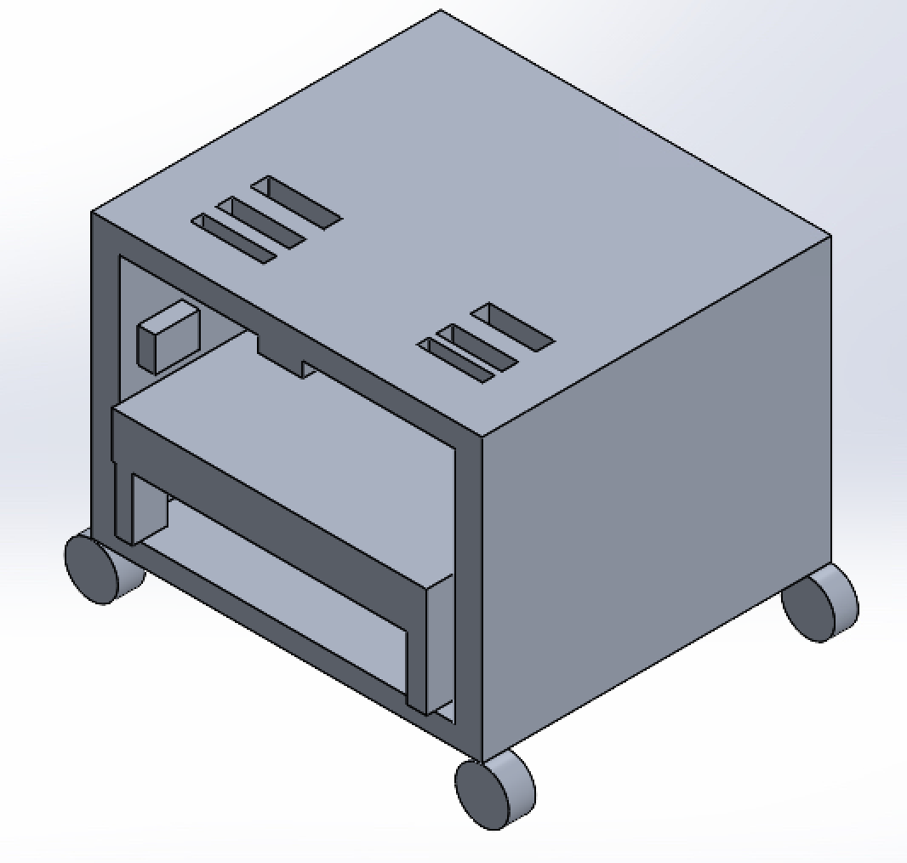

The preliminary SolidWorks model above highlights the most prominent features of our design. Major features such as the vents, power outlet, lighting, desk, and the wheels are shown. The remaining features as well as adjustments to dimensions and materials will be added during later stages of the prototyping process.

## Prototype Design Requirements

|  |  |  |
| --- | --- | --- |
| **Design Requirement** | **Threshold** | **Goal** |
| Effective energy conservation | 1200W-1800W | 1400W-1500W |
| Time to dismantle for transportation and storage | 15 to 30 minutes | <20 minutes |
| Weight bearing | >250 lbs | 350 lbs |
| Operating lifetime | >5 years | 7 years |
| Noise Canceling Capabilities | 50 to 130 decibels | >110 decibels |
| Size | 6x6in - 9x9in | >8x8in |

Energy conservation determines the amount of voltage we would design the outlet to be able to handle.

The time to dismantle is for the convenience of the user and the design of our pod would allow the user to be able to dismantle and transport the object in less than 20 minutes. This means that the way we design our product needs to be able to dismantle and fold for transport.

Weight bearing and noise canceling capabilities will affect what material we choose to use for our design. The material we use must be sturdy/strong in order to handle the weight capacity but also it needs to have noise canceling capabilities. An option for this material would be a soundproof foam material that will keep noise out of the pod and be lightweight enough to transport easily.

The operating lifetime will be fulfilled using lasting materials and a well-made design that has minimal wearing capabilities.

The size of the design in Solidworks is going to be 8x8 inches.

## Testing Methodology/Verification Plan

We will verify the weight capacity and auditory dampening of the model through two Solidworks test. The first test will use a structural analysis test to determine how much weight the structure can hold. We will first test that it can hold 150 lbs and then test that it can hold 350 lbs. The goal is for it to pass both tests.

The second test that we will do in Solidworks will assess how much sound the structure can dampen. We will use the flow simulation noise prediction test to analyze this. We will important a part that makes a lot of noise into our Solidworks file with our Zoom Room. The Solidworks test will show us how quiet the surroundings of the part that is making the noise are. This will allow us to test how much noise our Zoom Room is dampening. We will find a part that makes 60 dB and 100 dB, and then see how loud the noise is inside the Zoom Room. The goal is for it to be no louder than 40 dB in both tests.

## Correlation Matrix & Scorecard

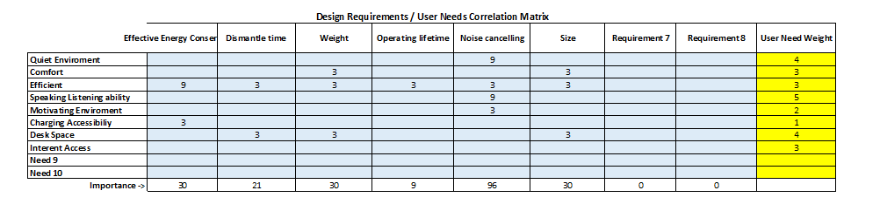

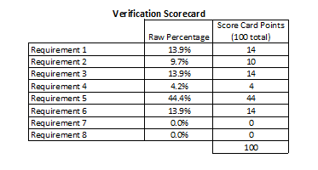

A correlation matrix was used to determine how certain design requirements are related to the user’s needs. The higher weighted requirements will be favored in the final design as well as in considering potential design tradeoffs. Based on the results of the design requirements matrix, the most important requirements that will be favored will be noise cancellation, weight/size requirements, and energy efficiency. Noise cancellation scored the highest meaning it will be a top priority in our design. The weight and size requirements also scored high due to the nature of the design being mobile and needing to be adequately sized. Finally, being energy efficient will be the third requirement we will direct the design toward; however, it will be less important than the other requirements discussed above.

## Prototype Detail Design

Due to the limitations of being all online, we decided that we could best work as a team on a Solidworks part. This would give the clearest view to all members of what the prototype was looking like. The limited experience of team members with manufacturing also indicated that this would be the best option. Additionally, using Solidworks will allow us to more accurately test the weight capacity and acoustic dampening of our model. It would be difficult to test both of these aspects in a physical model. We used Solidworks to model the sketch as a 3-D parts assembly. The following is the original sketch:

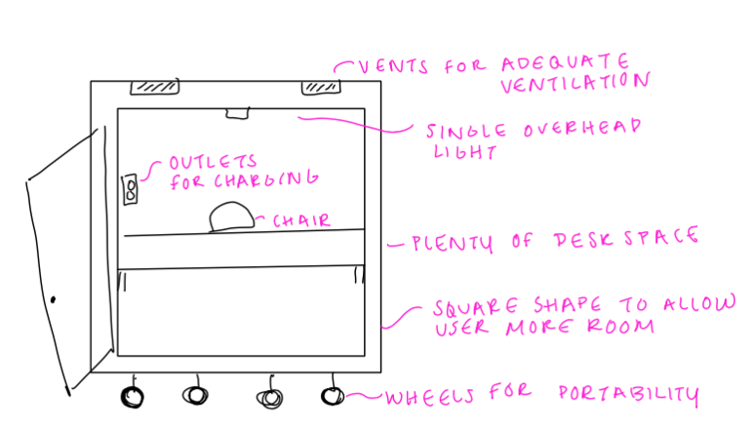

The following picture shows the isometric view of our Solidworks assembly. We made sure to add important features such as air vents, the desk, and the wheels. Additional features from the sketch can be seen upon further inspection, such as an outlet for charging and a chair. Modelling and testing our product in Solidworks is the final stage of prototyping that we will achieve. This protype can be used to showcase our design and gauge target audience interest.



# References

Cyr, M., 2021. *Online vs. In-Person Classes*. College Times: Required Reading. [http://www.ecollegetimes.com/online-vs-in-person-classesAccessed\](http://www.ecollegetimes.com/online-vs-in-person-classesAccessed/)

Meinke, H. (2020, July 27). *What i wish someone told me before taking online classes*. Rasmussen University. Retrieved September 12, 2021, from <https://www.rasmussen.edu/student-experience/college-life/what-i-wish-someone-told-me-before-taking-online-classes/>.

Rimer, Sara. “BU Students on Zoom vs In-Person Classes? It's Complicated.” *Boston University*, 9 Nov. 2020, [www.bu.edu/articles/2020/students-learn-from-anywhere/](http://www.bu.edu/articles/2020/students-learn-from-anywhere/).

Searle, Isabella (Isa). “Zoom Classes Get Mixed Reviews from Students.” *The Mirada*, 15 Sept. 2020, [www.riomirada.com/news/2020/09/15/zoom-classes-get-mixed-reviews-from-students/](http://www.riomirada.com/news/2020/09/15/zoom-classes-get-mixed-reviews-from-students/).

Dean, Brian. “Zoom User STATS: How Many People Use Zoom in 2021?” *Backlinko*, 10 Mar. 2021, backlinko.com/zoom-users#zoom-app-age-demographics.

Amenabar, Teddy. “How College Students Can Make the Most of Remote Learning.” *The Washington Post*, WP Company, 5 Sept. 2020, [www.washingtonpost.com/education/2020/09/06/remote-learning-college-zoom/](http://www.washingtonpost.com/education/2020/09/06/remote-learning-college-zoom/).

*The NCES Fast Facts Tool provides quick answers to many education questions (National Center for Education Statistics)*. National Center for Education Statistics (NCES) Home Page, a part of the U.S. Department of Education. (2021). Retrieved October 8, 2021, from <https://nces.ed.gov/fastfacts/display.asp?id=372#K12-enrollment>.

Getahun, H. (2021, March 31). *The race for space: How today's crowded study environments could affect college students' performance*. CalMatters. Retrieved October 8, 2021, from <https://calmatters.org/education/higher-education/college-beat-higher-education/2021/03/crowded-study-spaces-college-students/>.

Mueller, P., & Havsy, J. (2020, January). *Student Housing Research Report final - NMHC*. Retrieved October 8, 2021, from <https://www.nmhc.org/globalassets/research--insight/research-reports/student-housing/student-housing-research-report-final.pdf>.

Minhas, S., Hussain, T., & Sajid, K. (2021). EXPLORING STUDENTS ONLINE LEARNING: A STUDY OF ZOOM APPLICATION. *Gazi University Journal of Science*.

# Appendix A

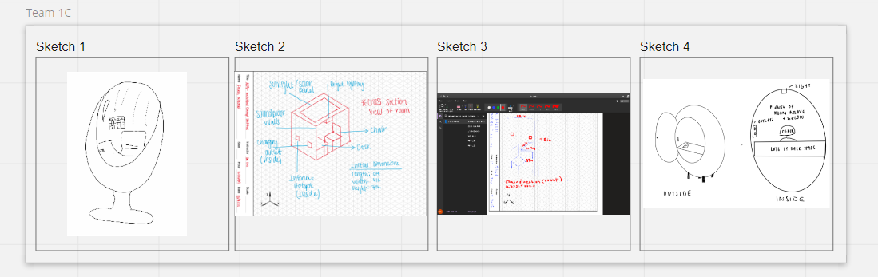

Miro Board Brainstorming

**Team Working Agreement**

Autumn 2021

1. Group Information

Lab Section #: 28368

Table Letter: 1C

Instructor: Dr. Ita

GTA: Alexia Leonard

1. Contact information

|  |  |
| --- | --- |
| Mohammed Abdallah | [abdallah.69@osu.edu](mailto:abdallah.69@osu.edu) |
| Faleh Alzoubi | [alzoubi.2@osu.edu](mailto:alzoubi.2@osu.edu) |
| Bella Scholtes | [scholtes.4@osu.edu](mailto:scholtes.4@osu.edu) |
| Victoria Smith | [smith.14610@osu.edu](mailto:smith.14610@osu.edu) |

1. Team Goal

As a team we will strive to work together to achieve the best possible outcome in every assignment. Every member will have to put equal amounts of effort into every project to make it the best possible. Roles will be distributed evenly and fairly so everyone does the same amount of work and not one single member does most of the work. All members should contribute to assignments and in meeting to reach the best results as group.

1. Meetings

The group will communicate through a Group Me group chat and email. Group chat messages will be sent out at least once every week to go over the coming assignments. Group members are expected to respond to messages on group me or emails within 24 hours. If we need to meet on zoom, we will do so on a Tuesday, Wednesday, or Sunday, and the time will be decided in the team Group Me. If any unexpected conflict arises, we will set up an emergency meeting through Group Me to discuss when is the best time for all to meet. Furthermore, the group will use breakout room time to discuss assignments, due dates, questions, comments, and concerns any member might have. Due to difficulty of scheduling meeting outside of class, members should use breakout room time to participate as much as possible.

1. General Team Member Expectations

Each team member is expected to attend all lectures/labs in order to keep up to date with the materials so they can participate in our weekly meetings. If a team member must miss a section, they are expected to communicate that to their other team members. Workload, brainstorming, and development will be equally split between each team member. All members will do the tasks that need to be done while working with each other when they need help. Each team member must be responsible with their time and their teammates time in order to get assignments done by the deadline. Each team member is responsible for participating and contributing to group discussions. Each team member must be respectful and understanding of other team members. Each team member is to be held accountable for their portion of the project and assignments. Each team member is to give constructive feedback to the other team members. Team members should communicate issues and conflicts respectfully. Team members should communicate often or when questions or suggestions arise for an assignment. Team members are expected to work on their part of the assignment early so that we don’t rush the assignment and turn in the best possible product.

1. Individual Team Member Responsibilities/Deadlines

Mohammed Abdallah – Creating and sharing documents (Ex. a word doc) for the group to work together on.

Faleh Alzoubi – Note taking during brainstorming and development.

Bella Scholtes – Schedule and send out zoom meeting links.

Victoria Smith – Review assignment and corresponding rubric and submit group assignments.

1. Conflict Resolution

Team members should speak about any problems or conflicts that arise. If any conflicts arise, all members of the team will meet at our weekly zoom meetings and address the problem. All team members will work together to formulate a good solution to the problem that everyone agrees with. If this conflict cannot be resolved by this method, the instructional team will get involved to work out a solution that works best.

1. Expectations of Faculty and GTAs

If a team member fails to comply with this agreement, the situation will be reported to the staff. The team will continue to be responsible for submitting all assignments. Staff will be available to meet with teams to resolve issues. Staff are expected to help resolve team disagreements in the fairest way possible.

1. Team Signatures

Mohammed Abdallah

MBA



Faleh Alzoubi



Bella Scholtes

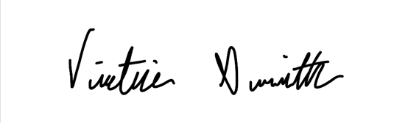

Victoria Smith

Appendix B

|  |  |  |  |
| --- | --- | --- | --- |
| **Project Manager for Assignment** | | | |
| Faleh Alzoubi | | | |
| Deputy Manager for Assignment | | | |
| Victoria Smith | | | |
| Drafted Assignment | Reviewed Assignment | Revised Assignment |
| Faleh | Mohammed Abdallah | Bella, Victoria |
| Other Contributions | | | |
| Brainstorming _ Bella  Victoria – Assignment research | | | |
| Problems Overcome | | | |
| Finding right measurements for concept  Identifying requirements | | | |